**WEEK-2**

**EXERCISE 1: SETTING UP Junit**

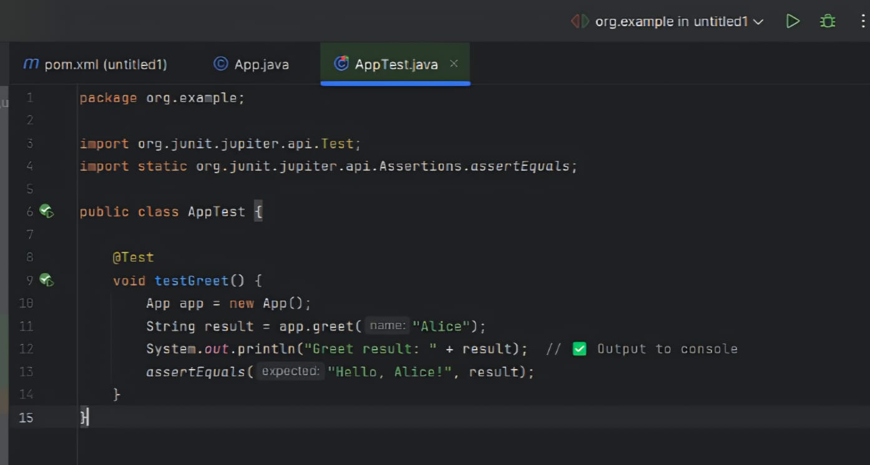

OUTPUT:

